**Team Meeting week of 3/27**

Need to set date/time, how about Sunday @ 6pm, or Monday @ 6pm?

This agenda serves as a guide/preliminary decision making prior to the meeting, just to get all of us thinking about what needs to be done so that we can finalize and move forward during our meeting here in the next few days.

There are a few items/decisions that need to be finalized, as well, we need to move forward asap to the prototyping stage.

**Ordering:** We need to get things ordered ASAP. With this term coming to a close, and lead times stacking up, we need to get everything that we need ordered and on it’s way. Hopefully we can get everything finalized and ordered by the end of the week, 3/31/17. Preferably, we need to order enough key items so that when things arrive in 2-3 weeks we can construct at minimum 2 or 3 prototypes for testing. With how much time we have left coupled with lead times for all of these materials/parts, if something needs to be changed we will likely only have time for 1 iteration if we only order enough for 1 or 2 prototypes at a time. Things that still need to be ordered with extensive lead times are as follows:

-Nomex

-PTFE

-Teflon bag liner(<http://www.welchfluorocarbon.com/custom-manufacturing/heat-sealing/>)

-Aluminum for in house machining

-Mating Rings

-Endcaps

-Additional fasteners/fittings for hydro testing

-???

In regards to the list above, we can move on to a few discussion items/decisions as detailed below.

**Mating Rings, Endcaps, In-House Machining**

*In-House Machining:* I do believe this is a good idea for the low cost, open source nature of this project. However, there will be a fairly steep learning curve as none of us have extensive machining experience, not to mention we will need to arrange time with Mike/others in the machine shop to show us everything/supervise etc. As well, we are working within some tight tolerances so there will definitely have to be some practice involved. It has been discussed between a few of us already that we may want to lean towards sending off designs to a local shop to have them do it for us. I propose that we do both. Since lead times are involved, I propose we send off designs to a machine shop (minimum 2 replicates so we can construct at least 2 prototypes) to be professionally machined. This is so at the very least we will be able to have in our possession rings/caps that WILL work within our tolerances. This will require CAD models being finalized/drawings created by early in the week so that we can get quotes and send off to a shop. Since this will likely involve at least a week or 2 lead time, we can get ahold of aluminum and use this time to try and beat the learning curve in the machine shop and practice fabricating pieces ourselves.

|  |  |  |  |
| --- | --- | --- | --- |
| **Name** | **Agree** | **Disagree** | **Comments** |
| Neil | + |  |  |
| Russell | + |  |  |
| Alex | + |  |  |
| Francesca | + |  |  |
| Chris | + |  |  |
| Weldon |  |  |  |

*Mating Rings:* These designs are nearly final, though with Alex discovering the Teflon Heat Liner ( <http://www.welchfluorocarbon.com/custom-manufacturing/heat-sealing/>), it makes me think this may in fact be a cheaper and quicker option than the PTFE, while still achieving the same desired effect & quality of tank. If we elect to use this ‘teflon bag’, it means that the ring designs will change slightly. As mentioned above, I think we could in fact do both, especially if we send off designs to a machine shop. We will just have them fab the 2 different designs, and we can compare layup procedures/effectiveness of each if we construct both models. This can also be accomplished by us in the machine shop while we are waiting on lead times. These are the designs that I am thinking of:

(1) Same PTFE design with offset lapping portion to allow PTFE to be inner layer of the tank:

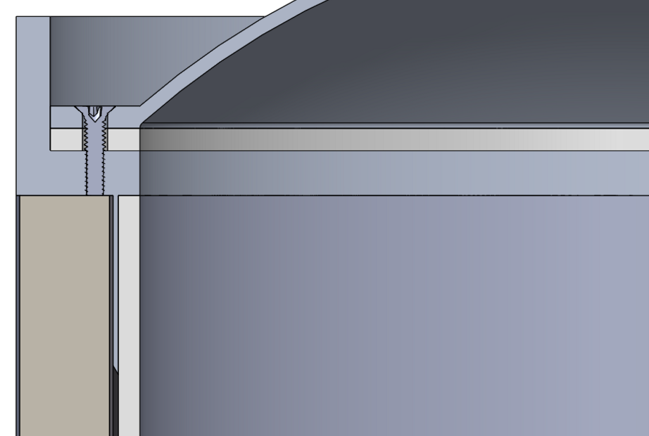

(2) Alternate design for Teflon Bag, with no offset portion, similar to below:

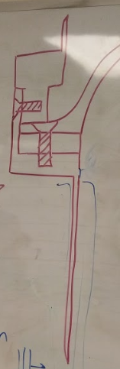

Using this secondary design with a teflon bag, we could even potentially ‘double line’ the interior, incorporating one layer into a layup, and then lining the inside of the tank a second time post curing process.

|  |  |  |  |
| --- | --- | --- | --- |
| **Name** | **Agree** | **Disagree** | **Comments** |
| Neil | + |  |  |
| Russell | + |  | I think we exhaust the liner possibilities before giving up and moving to the bag. I think there is a possibility that we can lay up onto a thicker tube, then bore it out afterward with the challenge of getting a good surface finish. |
| Alex | + |  | Our current liner design is the better option, but at least the bag can serve as a backup. |
| Francesca | + |  | ^This^ |
| Chris | + |  |  |
| Weldon |  |  |  |

*End Caps:* As discussed preliminarily between a few of us, I think the end cap design can be simplified to just a flat plate design. Under our operating pressures having a curved geometry for an end cap is likely unnecessary, as the stress concentrations will be occurring at the joining interface and fasteners of the tank. Not to mention a flat end cap would be much easier to machine, both in house and by a machine shop. We could move forward with this alteration of a design for at least the initial prototyping stage, and if it appears that we need to alter them back to a curved geometry then we have that possibility.

|  |  |  |  |
| --- | --- | --- | --- |
| **Name** | **Agree** | **Disagree** | **Comments** |
| Neil | + |  |  |
| Russell | + |  | What Francesca said, but we can always use a nipple with gaskets and nuts, which won’t handle as much pressure, but may handle enough |
| Alex | + |  |  |
| Francesca | + |  | If we are doing a flat plate, I think we should consider shaving down a thicker plate to allow for a thin wall with a thicker center-section that can be tapped through and used to mount inlet/release valves |
| Chris | + |  |  |
| Weldon |  |  |  |

*Additional Considerations:* If we can get everything ordered and underway, we will have a couple weeks of just waiting around for things to get here. During this time, as mentioned above we can work in the machine shop, but as well work on acquiring additional necessary resources, as well as performing tests. More coupons can be created for thermal cycling, which means we can find a source of liquid nitrogen for said testing (hopefully from the PSU chem department for ease of access), as well as methodology and a location to be able to perform these tests. Also, if we can get a sample of the teflon bag in our possession rather quickly it would be nice to run a set of coupons using this material as we have with the PTFE to see how it holds up against METLBOND and the CF curing procedure.

*Adhesive*: Need to look into backup adhesive (do some research into company Masterbond), in case METLBOND isn’t going to cut it..

DECISIONS:

-Move forward with Flat End Cap

-Move forward with 0.25” wall thickness PTFE, 3” ID, with etching, get quote, get it rdy to order asap (5 replicates)

-Fab 2 designs, one for teflon bag, one current design